Rainbow Slaw
Amy Symington
Preparation Time: 20-25 minutes

Ingredients

6 servings
¼ large head (300 g) red cabbage, julienned
¼ large head (275 g) green cabbage, julienned
1 large (150 g) carrot, grated
¼ (30 g) yellow pepper, julienned
¼ (30 g) orange pepper, julienned
¼ (30 g) red pepper, julienned
Dressing
¼ cup (60 ml) extra virgin olive oil
1 tsp (1 g) lime zest
1 tbsp (15 ml) lime juice, approximately 1 lime
1 clove (3 g) garlic, minced
4 ½ tsp (22 ml) maple syrup
¼ tsp (1.25 g) salt

Garnish
1 sprig (15 g) green onion, thinly sliced
1/8 bunch (7.5 g) cilantro, leaves removed and stems minced (optional)
24 servings
1 large head (1.2 kg) red cabbage, julienned
1 large head (1.1 kg) green cabbage, julienned
4 large (600 g) carrots, grated
1 (120 g) yellow pepper, julienned
1 (120 g) orange pepper, julienned
1 (120 g) red pepper, julienned
Dressing
1 cup (250 ml) extra virgin olive oil
1 tbsp (4 g) lime zest
¼ cup (60 ml) lime juice, approximately 4 limes
4 cloves (12 ) garlic, minced
6 tbsp (90 ml) maple syrup
1 tsp (5 g) salt

Garnish
3 sprigs (70 g) green onions, thinly sliced
½ bunch (30 g) cilantro, leaves removed and stems minced (optional)

Directions
- In a large bowl, toss together all salad ingredients.
- In a small bowl whisk together dressing ingredients.
- Add dressing to salad and toss.
- When ready to serve, garnish with green onions and cilantro (if using).

Nutritional Information
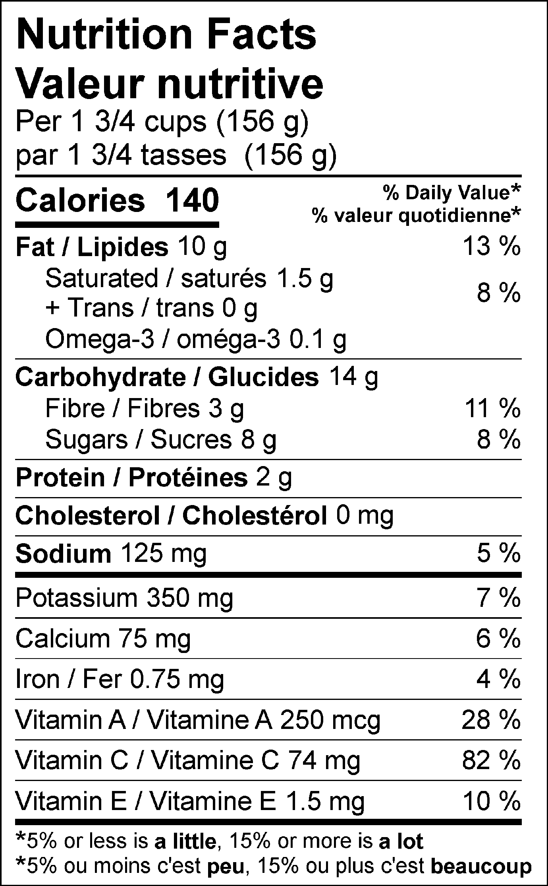

Intro:
As they contain the highest amount of phytonutrients, consuming colourful vegetables and fruits is the best way to keep chronic diseases at bay and this recipe will help you do just that. For those last minute meals, keep it in your fridge undressed for a quick and nutrient dense side. Conveniently, it can also double as a fun and tasty sandwich, taco, or burrito topping. So go ahead and eat that rainbow!

Symbols: high source of fibre, good for bowel motility and nausea, kid friendly, good for all seasons, easy to swallow, nut free, soy free

Functional foods present: cruciferous vegetables (cabbage), orange vegetables (carrots and orange peppers), red vegetables (red peppers), citrus fruit (lime), allium vegetables (onions, garlic), leafy greens (cilantro)

Examples of phytonutrients and anti-oxidants present: flavonoids (cruciferous vegetables), carotenoids (orange and red vegetables, leafy greens), allicin (onions, garlic), vitamin C (citrus fruit)

